Due Diligence Report

FL-Marion-9036-1154-05
Property Details

Owner Name | NOEL LYONEL, GUSTAVE ALTA GRACE
Owner Address | 8223 WHITE ROCK CIR BOYNTON BEACH FL 33436-1745
Assessor’s Parcel Number | 9036-1154-05

Property Facts

Address | Fisher Ter
County | Marion
State | FL
Subdivision/Block/Lot | SILVER SPRINGS SHORES UNIT 36 BLK 1154 LOT 5
Legal Description (unofficial) | Lot 5, Block 1154 of SILVER SPRINGS SHORES UNIT NO.36, according to the Plat thereof as recorded in Plat Book J, Page(s) 312-319, of the Public Records of Marion County, Florida.
T R S | T-17, R-24, S-02
Parcel Size | 0.27
Number of Parcels | 1
GPS Coordinates | Latitude/Longitude Elevation  Center 29.04213 -81.874481 78.74 ft  NW 29.04234 -81.874431 78.74 ft  NE 29.042136 -81.87422 78.74 ft  SW 29.042111 -81.874721 78.74 ft  SE 29.041928 -81.874528 78.74 ft
Google Map Link | https://maps.app.goo.gl/v4RoKjwyVmmVqAGA6

Property Record | https://www.pa.marion.fl.us/PRC.aspx?key=2488158&YR=2024
Previous Transfer Info | Deed Type Warranty Deed  Deed Transfer Date 07/22/2004  Deed Record Location File Number 2004105391 Book/Page: 3778/1187

County Website Information

County | https://www.marionfl.org | (352) 438-2300
Assessor | https://www.pa.marion.fl.us | (352) 368-8300
Treasurer | https://www.mariontax.com | (352) 368-8200
Recorder/Clerk | https://nvweb.marioncountyclerk.org/searchng_SSL/default.aspx | (352) 671-5630
Planning/Zoning | https://www.marionfl.org/agencies-departments/departments-facilities-offices/growth-services/planning-zoning | (352) 438-2600
GIS Website | https://www.marionfl.org/i-want-to/view/maps
Property Tax Information

Assessed Property Value | $4,235
Actual Property Value | $16,000
Back Taxes Owed | $0.00
Tax Liens | $0.00
Annual Property Taxes | $100.56
Actual Property Details/Information

Access Road | Fisher Ter, Fisher Way Dr, Fisher Way Trce
Road Surface | Paved
Road Maintenance | County
Elevation (ft) | Low: 78.74 ft  High: 78.74 ft
Flood Zone? | NO

Terrain Type | Flat, Plain, Vegetation
Closest Highways | US Route 441, US Route 301, State Road 19, State Road 35, State Road 40
Closest Major Cities | Ocala, Palm Coast, Dunnellon, Orlando
Closest Gas Station | Mobil
Closest Grocery Store | Ray's Grocery, Qwik Food Stores LLC, Family Dollar, Dollar General
Nearby Attractions | Silver Springs State Park, Straight and level Seaplanes - Lake Weir, Big Boots & Western Railroad, Fort King National Historic Landmark, Appleton Museum of Art, Tuscawilla Art Park, Brick City Adventure Park, Carney Island Recreation & Conservation Area, Marion County Museum of History and Archaeology.

County Details

Zoning | SINGLE-FAMILY DWELLING DISTRICT
Property Use Code | R-1
What Can Be Built? | House
Time Limit To Build? | The time limit to build a structure in Marion County, Florida, can vary depending on several factors, including the specific zoning regulations and permitting requirements for your property. These regulations can change over time and may vary depending on the location within the county and the type of structure you plan to build. It is essential to check with the Marion County Building Department or the local municipal government where your property is located to get the most accurate and up-to-date information regarding building timelines and permitting requirements for your specific project. The contractor licensing division must ensure contractors working in Marion County are properly licensed by Marion County &/or the state of Florida. A contractor licensing representative maintains records for the division & conducts a license check for each new permit. Building inspectors & code enforcement officers will visit sites in the field to ensure projects are permitted. 352-438-2400
What Can You Do On/Near Property | Reside
Camping/Notes | No Camping is allowed unless it's in an RV Park or Campsite.
RVs/Notes | A manufactured home, park trailer or travel trailer may be used as a temporary residence incidental to construction on or development of property for a residential use on which the manufactured home, park trailer or travel trailer is located only during the time in which construction or development is actively underway with an active building permit, and in no case for more than six months, subject to renewal. Except that a manufactured home is prohibited from use as temporary residence on R-1 zoned property. Such use is subject to the approval of the Growth Services Director  A single recreational vehicle which has a self-contained disposal system shall be permitted to be occupied in any residential zoning as a non-commercial guest of the resident of the property involved, for a period not to exceed 21 days in any 60-day period by a Temporary Use Permit through the Growth Services Planning and Zoning Division.  Recreational vehicles which have a self-contained disposal system shall be permitted to be occupied in any agriculture zoning as a non-commercial guest of the owner or resident of the property involved, for a period not to exceed 60 days in any 365-day period. A limit of five travel trailers or recreation vehicles is permitted at one time by a Temporary Use Permit through the Growth Services Planning and Zoning Division, six or more by Special Event Permit with the approval of the Marion County Department of Health and the County Administrator.
Mobile Home/Notes | No person shall park or store a mobile home in any residential district except in a completely enclosed structure; provided, however, that this provision shall not apply in MH districts. Travel trailers may be parked or stored in residential districts, but not for living purposes, in rear yards but not in required side yards, or in front yards further streetward than the building line of the residence except as provided in section 122-245(6).  No person shall occupy a mobile home for living purposes except:  Such use is permitted in an approved mobile home park or mobile home subdivision, except as provided in section 122-245(6).(2)A person may occupy a mobile home in any residential district as the guest of the resident of the property involved for a period of not over 15 days in any 60-day period.
Water | Would need to dig a water well
Sewer/Septic | Would need to install a septic system
Electric | Power in the area – Duke Energy works in the area.
Gas | Use Propane tanks.
Waste | Residents who live in unincorporated areas of the county pay an annual assessment fee to use the recycling centers at no additional cost, but also have the option to contract with private franchise haulers for curbside pickup & other services.  All residents of incorporated areas within the county, businesses & those wanting to dispose of more than what is accepted at the recycling centers can use the Marion County Baseline Landfill.  Phone: 352-671-8465
HOA/Fees | Not part of an HOA

Photos

Nearby Property Bounds | 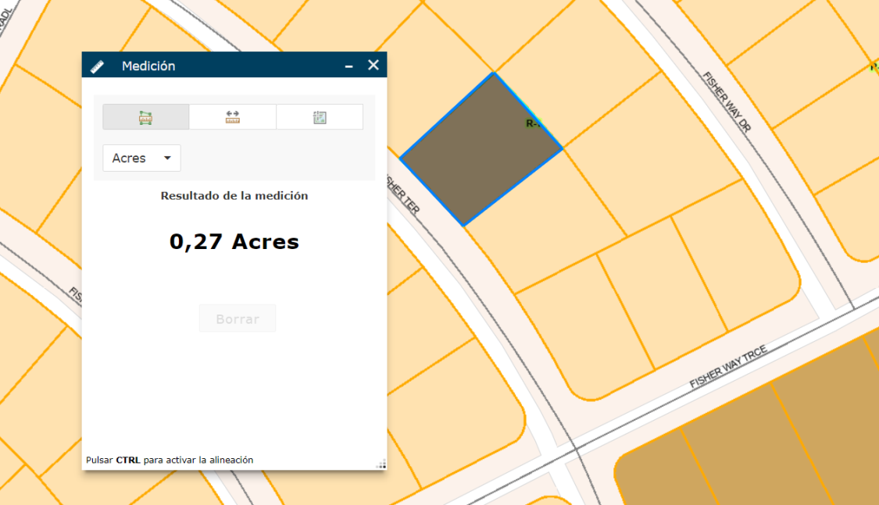
Close Up | 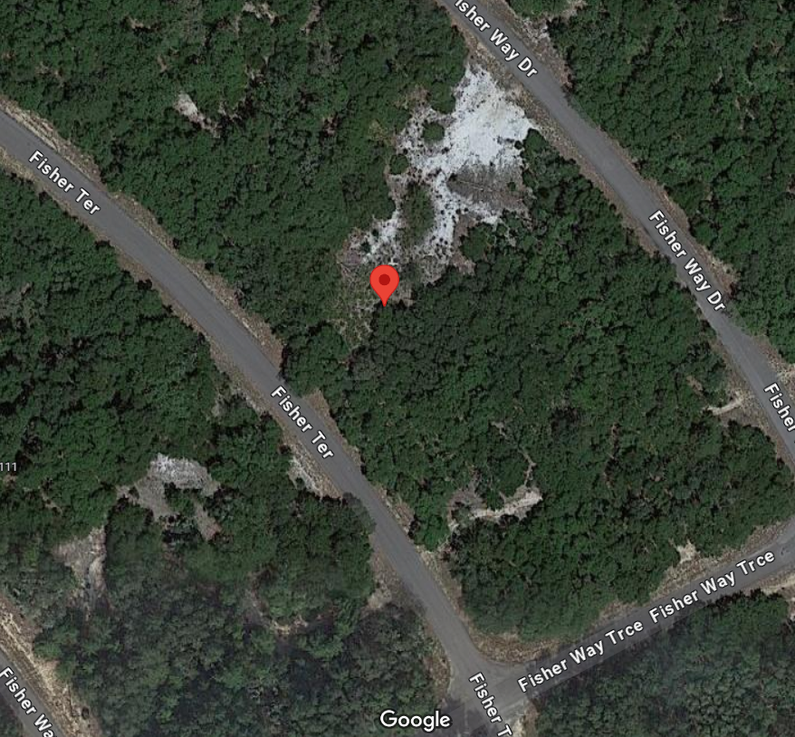
Main Roads Overview | 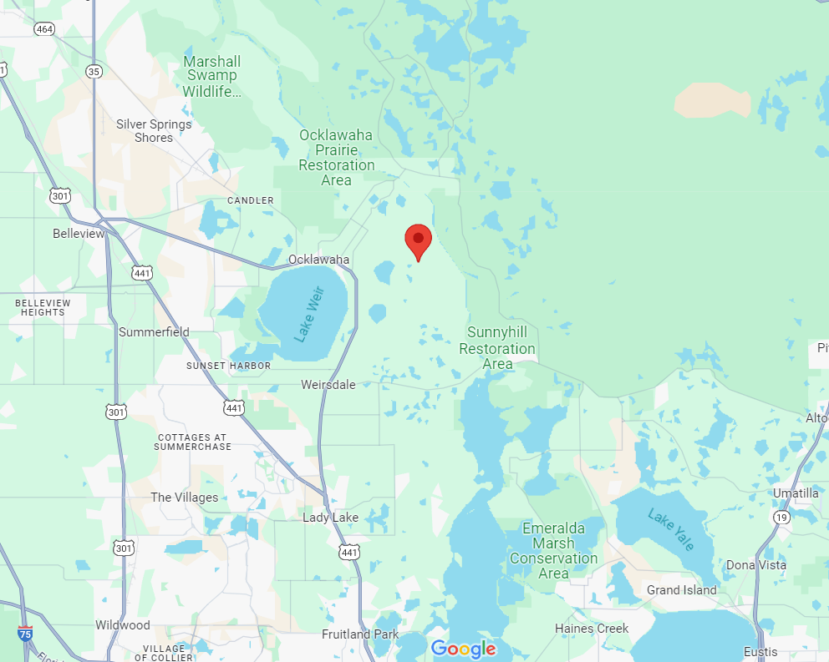

Terrain | 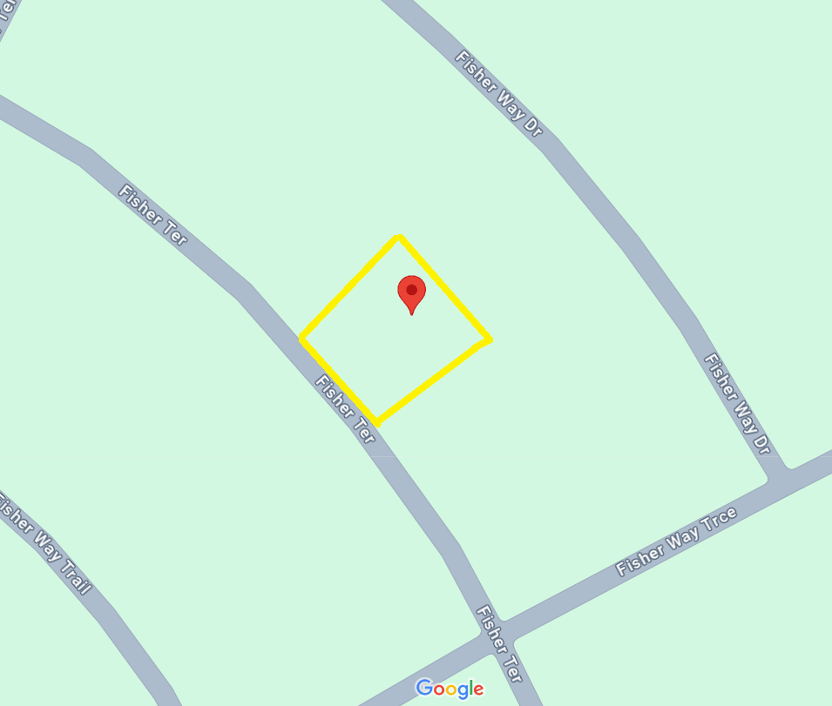
Aerial | 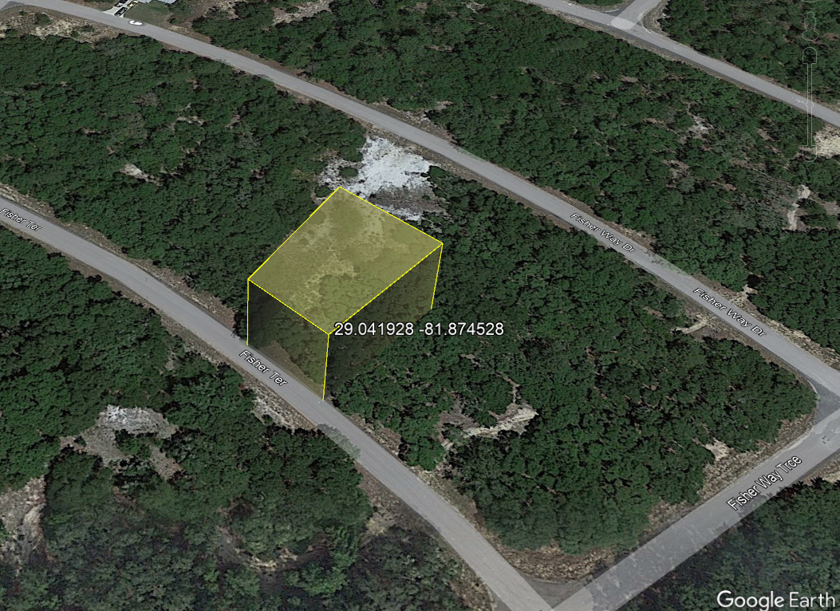

GIS | 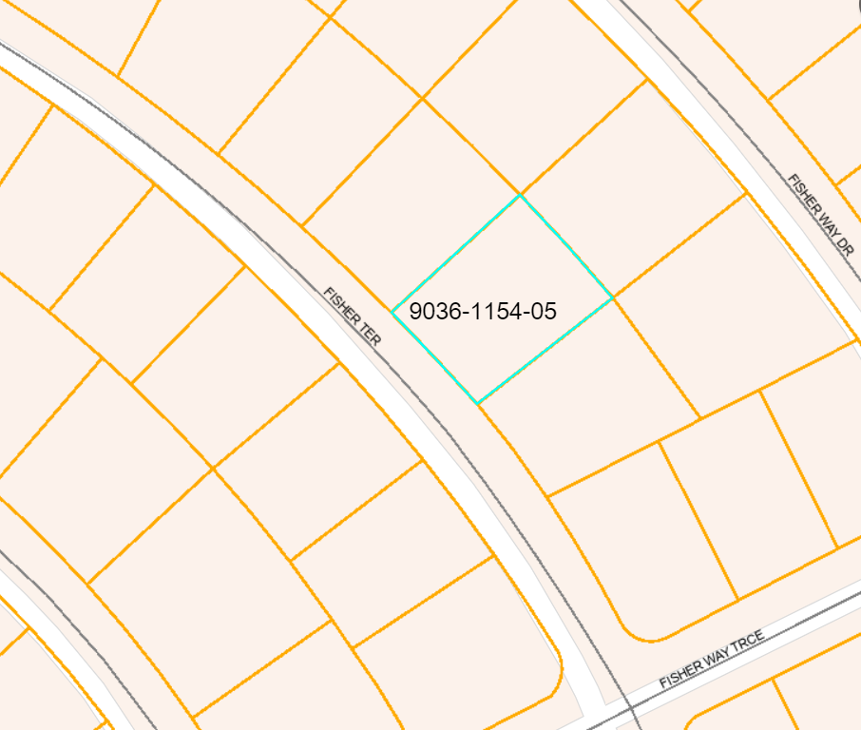
Street | 